Orb Bakery - Over Real Breads
50 Mill Road, Over, CB24 5PY; Tel/text: 07506 017001; email: orbbakery@gmail.com
ORDER FORM #94 | PLEASE RETURN BY  THUR 3rd Sept 2015  OR email your order (address above)
Customer Name | Please complete name
Collection Day | SATURDAY after 8.30am  Or Fridays if you get your order to us early in the week  (if we go out we’ll leave orders in box near front door –Address above)

Orb Breads
 | Product |  | Price | Number | Cost
French Country sourdough | Cob | Half | £1.80
 | Cob | Large | £3.00
Granary | Tin | 800g | £2.60
 |  | 400g | £1.60
 | Cob | 800g | £2.60
 |  | 400g | £1.60
Challah Bread | A Jewish festive bread – covered in poppy or sesame seeds |  | £1.90
Milk Loaf | Tin | Large | £2.70
 |  | Small | £1.70
Rye Sourdough | Russian Seeded (500g) | Tin | £2.60
 | The Borodinsky  (coriander seeds) (500g) | Tin | £2.70
100% Spelt Bread | Mostly white some wholemeal, 100% organic flour (400g) | Tin | £2.50
White Baps | Seeded or Sesame | 2 rolls | £0.85
 | Plain | 2 rolls | £0.85
White Bread | Tin | 800g | £2.20
 |  | 400g | £1.40
 | Cob | 800g | £2.20
 |  | 400g | £1.40
White Seeded Bread | Tin | 800g | £2.40
 |  | 400g | £1.60
 | Cob | 800g | £2.40
 |  | 400g | £1.60
Wholemeal Bread | Tin | 800g | £2.40
 |  | 400g | £1.60
 | Cob | 800g | £2.40
 |  | 400g | £1.60
Wholemeal Rolls | Seeded | 2 rolls | £0.90
Baguettes |  | 200g | £1.00
Walnut Bread  (with honey) |  | 550g | £4.00
TOTAL BREADS |  |  |  |  | £
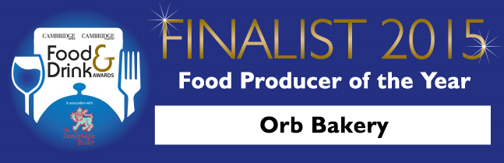

Orb Sweet Products
 | Product |  |  | Number | Cost
Biscotti | Orange, Almond and Date | 100g | £1.70
Bread Pudding | Two Puds | 280g | £1.60
Not Cross Buns | (Hot Cross Buns  without the Cross!) | Each | £0.85
 |  | 4 | £3.10
Muffins  (Please indicate flavour(s) and number) | 4* price is for 4 muffins of the same flavour | Each | £0.85
 |  | 4* | £3.10
 | Blackcurrant |  |  | tick
 | Blueberry |  |  | tick
 | Raspberry |  |  | tick
 | Apple & Blackberry |  |  | tick
 | NEW!! Raspberry & White Chocolate |  | £0.90 | tick
Bolus  (Sticky Cinnamon Buns) | Sold in fours | 4 | £1.80
NEW! Shortbread | Four Biscuits | 4 | £0.90
NEW! Scones | Plain | 2 | £1.30
 | Fruit (Sultana) | 2 | £1.40
CAKES |  |  | Prices
Coffee & Walnut |  |  | £3.50
Lemon Drizzle |  |  | £3.00
Chocolate & Banana |  |  | £3.00
Sticky Gingerbread |  |  | £3.50
Date & Walnut Tea Loaf |  |  | £3.50
TOTAL SWEET PRODUCTS |  |  |  |  | £
TOTAL BREAD PRODUCTS |  |  |  |  | £
TOTAL ORDER VALUE |  |  |  |  | £
Please note: being a home bakery if we only get a few orders for a particular product we may not have the capacity to bake this. We will contact you to discuss an alternative.

