Orb Bakery - Over Real Breads
50 Mill Road, Over, CB24 5PY; Tel/text: 07506 017001; email: orbbakery@gmail.com
ORDER FORM  Week #131  3rd Jun 2016 | PLEASE RETURN FORM or email by  WEDS for FRI or SAT am collections
Customer Name | Please complete name
Payment Options | Bank Transfer: Sort: 08 92 86; A/C 15423122 Account name: MR MARK T WEBB & MS C A NEWMAN  On the day: Bring cash with you when collecting – or put through letterbox if we are out (orders left in box outside).

Orb Breads
Product | Info | Size | Price | No. | Cost
Over the Hill  Beer Bread | Cob | 800g | £2.70
 |  | 400g | £1.80
Focaccia | Olive & Garlic |  | £1.40
 | Sun Dried Tomato & Garlic |  | £1.40
Pain de Campagne  (French Country Bread - sourdough) | Cob | 800g | £3.10
Granary | Tin | 800g | £2.60
 |  | 400g | £1.70
 | Cob | 800g | £2.60
 |  | 400g | £1.70
Challah Bread | A braided Jewish festive bread – covered in poppy seeds |  | £2.40
Milk Loaf | Tin | Large | £2.70
 |  | Small | £1.80
Rye Sourdough | Russian Seeded (500g) | Tin | £2.70
 | The Borodinsky  (coriander seeds) (500g) | Tin | £2.80
100% Spelt Bread | 50% white & 50% wholemeal, organic stoneground spelt flour (400g) | Tin | £2.60
White Baps | Seeded or Sesame | 2 rolls | £0.90
 | Plain | 2 rolls | £0.90
White Bread | Tin | 800g | £2.30
 |  | 400g | £1.50
 | Cob | 800g | £2.30
 |  | 400g | £1.50
Seeded White Bread | Cob | 800g | £2.50
 | Cob | 400g | £1.70
Wholemeal Bread | Tin | 800g | £2.50
 |  | 400g | £1.70
 | Cob | 800g | £2.50
 |  | 400g | £1.70
Wholemeal Rolls | Seeded | 2 rolls | £0.90
 | Plain | 2 rolls | £0.90
Baguettes |  | 200g | £1.10
Walnut Bread  (with honey) |  | 550g | £4.00
TOTAL BREADS |  |  |  |  | £
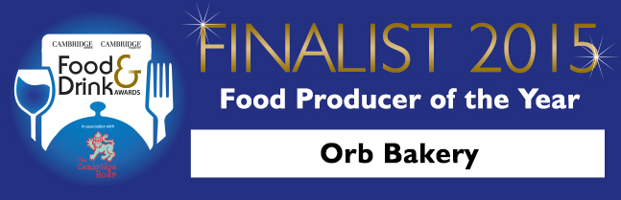

Orb Sweet Products
Product |  | Size | Price | No. | Cost
Biscotti | Orange, Almond and Date | 100g | £1.80
Bread Pudding | Two Puds | 280g | £1.70
Not Cross Buns | Hot Cross Buns without the cross! | Each | £0.90
 |  | 4 | £3.30
Muffins  (Minimum order 4 muffins) | Blueberry | 4 | £3.30 | tick
 | Raspberry | 4 | £3.30 | tick
 | Apple & Blackberry | 4 | £3.30 | tick
 | Raspberry & White Choc | 4 | £3.30 | tick
St Clements  Curdy Cakes | (filled with homemade  Orange & Lemon curd) | 4 | £3.30 | tick
Bolus  (Sticky Cinnamon Buns) | Sold in fours | 4 | £2.20
Shortbread | Four Biscuits | 4 | £1.10
Scones | Plain | 4 | £1.50
 | Fruit (Sultana) | 4 | £1.60
CAKES
Coffee & Walnut |  |  | £3.60
Lemon Drizzle |  |  | £3.20
Chocolate & Banana |  |  | £3.20
Sticky Gingerbread |  |  | £3.60
Date & Walnut Tea Loaf |  |  | £3.60
TOTAL SWEET PRODUCTS |  |  |  |  | £
TOTAL BREAD PRODUCTS |  |  |  |  | £
TOTAL ORDER VALUE |  |  |  |  | £
Please note: being a home bakery if we only get a few orders for a particular product we may not have the capacity to bake this. We will contact you to discuss an alternative.

